This is the procedure I follow; this is what is recommended:

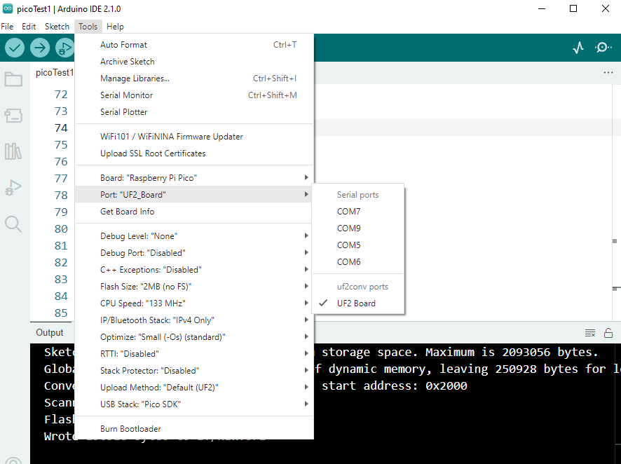

This is what I get after the boot sequence for the pico in my file folder RPI_RP2 (E:) is the pico file folder:
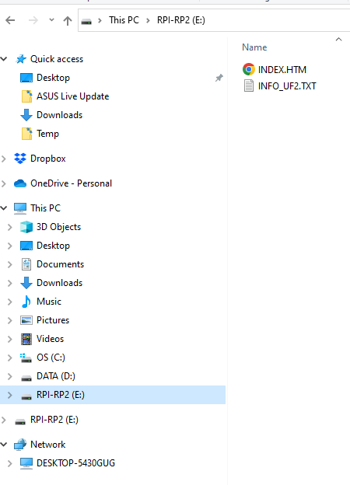
The compiled file shows in the pico file folder:
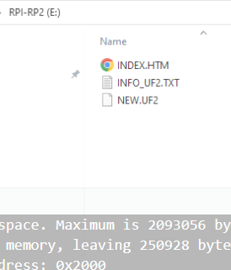

The port in the IDE has switched to another port that isn’t connected to the pico.
And the file is now closed by the IDE.

