Tester Project

Size: 200x155x45mm +-5mm

Power Source: 2x18650
Power duration (with the 2600mAh batteries I used)
-Around 25 hours without display backlight
-Around 9 hours with display backlight

Voltage Measurement

-Max measured voltage:20v
-Max current in parallel:920 mA

-Inaccuracy during tests*:
0,05v at 0,1v 50%
0,1v at 0,66v 15,1%
0,04v at 0,94v 4,3%
0,1v at 1,15v 8,7%
0,02v at 1,66v 1,2%

Resistance Measurement

-Max Measured Resistance:10kOhm

-Inaccuracy during tests *:
-1Ohm at 98 Ohm 1%
+2Ohm at 217 Ohm 0,9%
+23Ohm at 979Ohm 2,3%
+0,1k Ohm at 1,9kOhm 5,2%
+73Ohm at 1,9kOhm 3,8%
+0,8kOhm at 4,8 kOhm 16,7%

*In reference to a multimeter with 1,5% inaccuracy on resistance and 0,8% inaccuracy on dc voltage

Average error on voltage:15,8%
Average error on voltage above 0,5v:7,3%
Average error on resistance: 3,3%
Average error on resistance below 1kOhm:1,4%

Fritzing Schematic

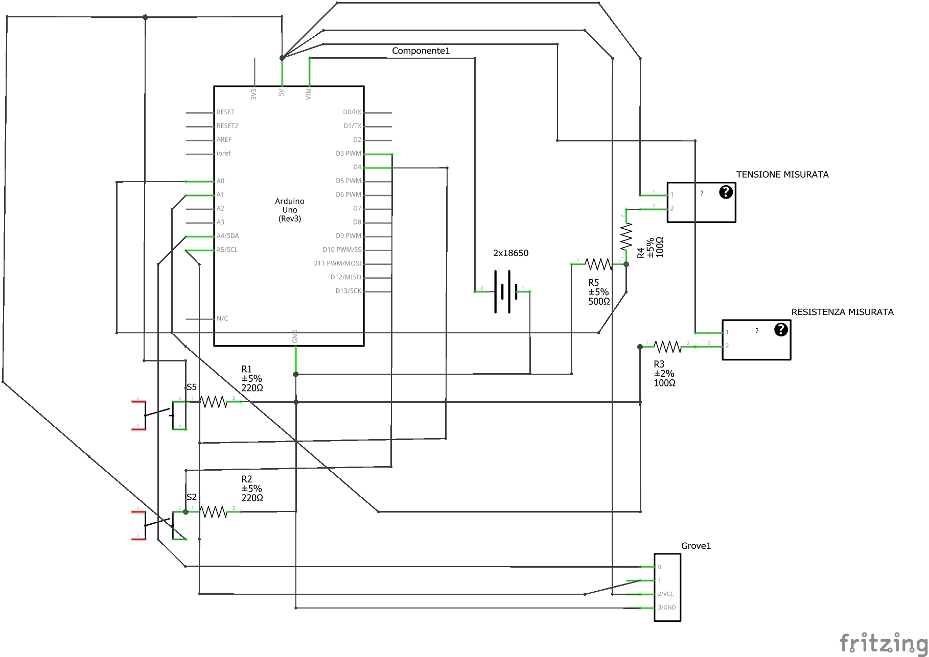
Notes:
-Grove 1 is actually the display.
I wanted to incorporate a Seeedstudio real-time clock but that idea was abandoned.
-The two ? boxes are the voltage (above) and the resistance (below)
-The schematic could be made tidier, but I don’t think it’s worth to download fritzing on another pc just to do that

