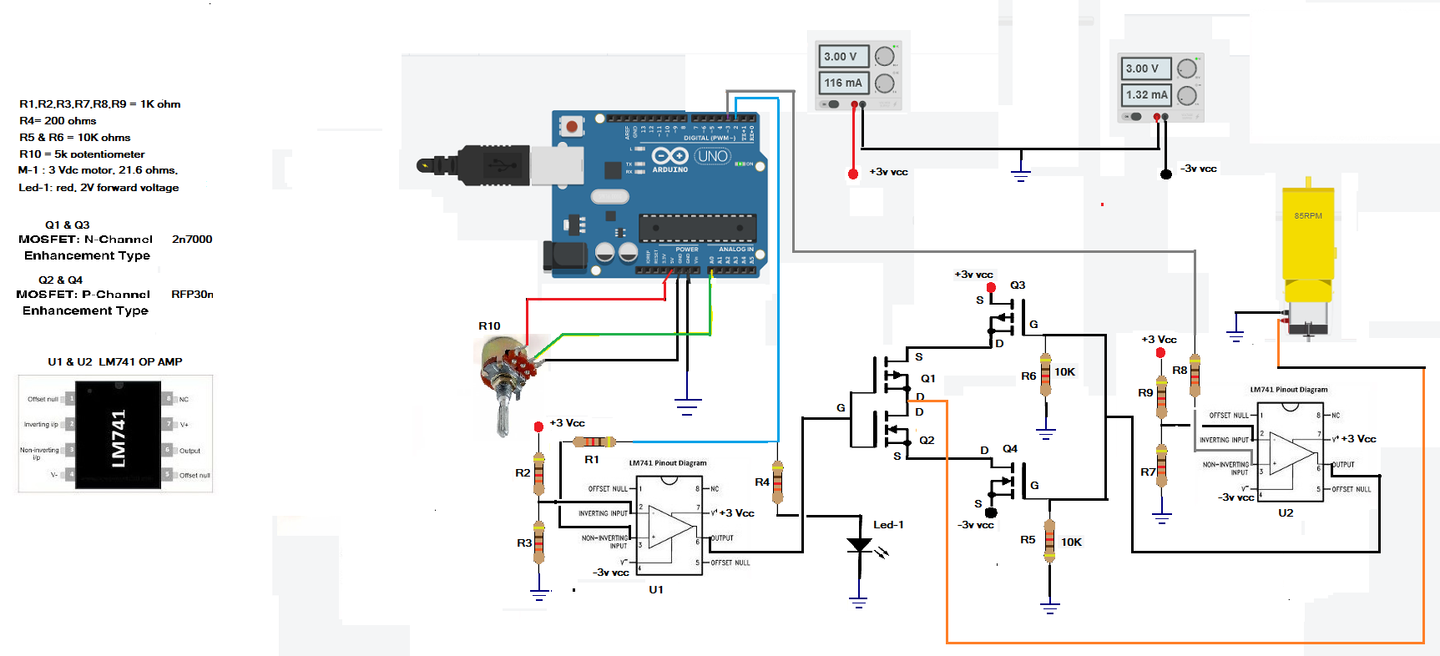
DC Motor control schematic

Conclusion: The circuit simulator seems to work just fine, showing that the software is working as is… The only thing changed is using pin 3 , a PWM pin, to substitute for the motor Cytronic motor contoller H-bridge control.
The circuit I built on the simulator is just a Mosfet H-bridge with direction and speed control. U1 is a LM741 used as a comparator to contol forward or reverse direction, and U2 is an LM741 also used as a comparator
to control the speed of the motor. The Mosfets are nMosfets, and pMosfets in a Bridge configuration..

