Pot is 4.9 v, Motor at –95 rpm , notice PWM waveform, led is just an direction indicator, on is reverse, off is forward.
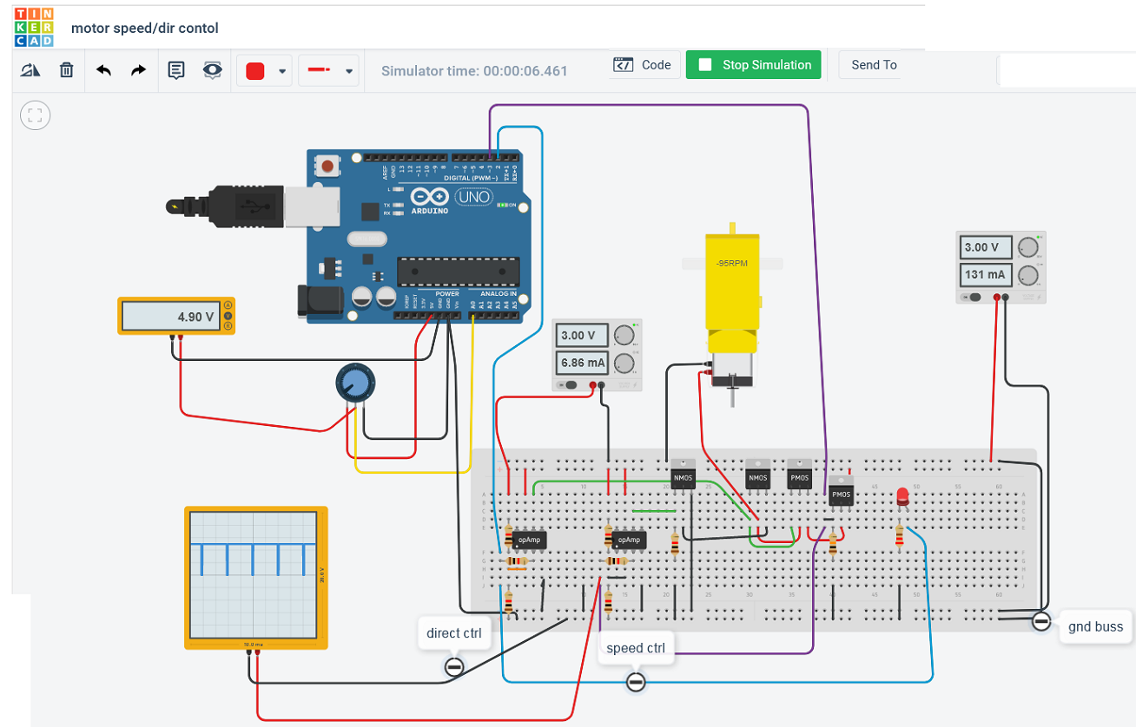

Pot (R10) @ near 0 vdc. Motor is @ 16 RPM, notice PWM Waveform


