Burning Bootloader onto ATMega328P-PU
1)
This is the example sketch. Make sure you do this before wiring up the Arduino in step 2. Leave the programmer as AVRISP mkII.
2) I wired up the Arduino Uno to the ATMega328P-PU using the following schematic provided by codecage on the DroneBot Workshop:
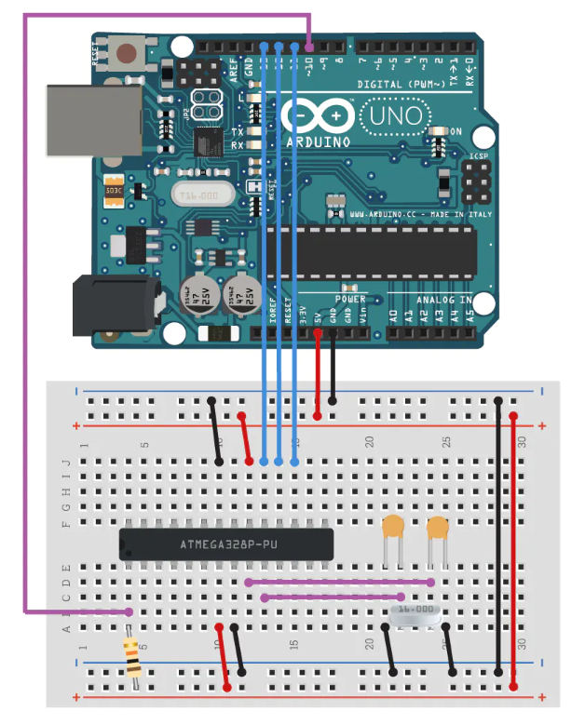
3) Select these settings:
"Arduino Duemilanove” for the Board and "Arduino as ISP" from Tools > Programmer
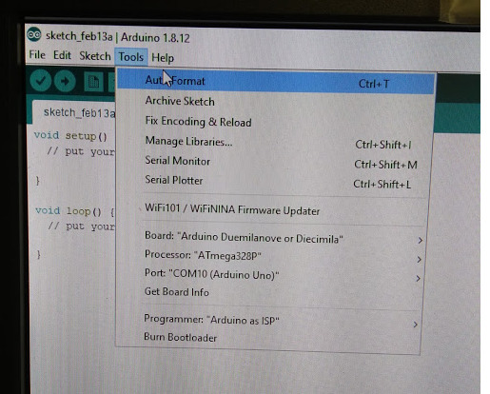
Click Tools > Burn Bootloader
I may have had verbose output on (I have verbose on Upoad turned on in the Preferences). Note: You can also select Arduino Uno as your board.
Loading Sketch onto ATMega328P-PU
On 2/14/2020 I took a bootloaded ATMega328P-PU and put it directly into the Arduino Uno board (after removing the original chip). These are the settings I used to load the Star Wars sketch:
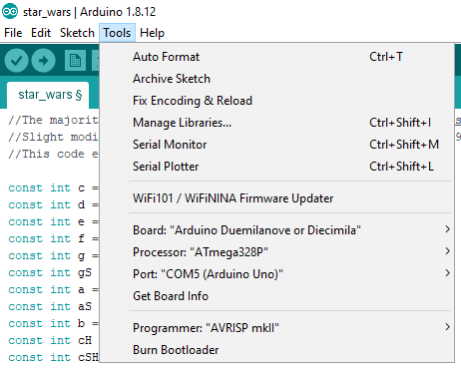
Note that I was using Windows 10 64 Bit and Version 1.8.12 of the Arduino IDE.
Note: If Arduino Uno was the board used to burn the bootloader it is also the board you have to use to load the sketch.

